Use-Case Realization Report (Requirements)
Coin Input and Select Brand

Issue 3.0
Revision History
Date | Issue | Description | Author
12 July 2000 | 1.0 | First Issue | Howard Russon
20 July 2001 | 2.0 | Revised for MTech Unit 3 in 2001 | Howard Russon
22 July 2004 | 3.0 | Revised for MTech Unit 3 in 2004 | Howard Russon

Table of Contents
1. Brief Description 4
2. Flow of Events 4
2.1 Standard Flow 4
2.2 Exceptions 4
3. Interaction Diagrams 6
3.1 Domain Collaboration Diagram: Coin Input and Select Brand 6
4. Participating Objects 6
5. Class Diagrams 8
5.1 Domain Class Diagram: Coin Input and Select Brand 8
6. Derived Requirements 8

Use-Case Realization Report
Coin Input and Select Brand

Brief Description
This use case enables the Customer to buy drinks from the vending machine by selecting a brand from those available, and then entering coins to pay for the selection. Invalid coins will be returned. Provided the required amount of money is entered, the selected brand will be dispensed to the customer. Change will be given if more money than the price of the drink is entered. The Customer will be permitted to terminate the purchase prior to the selected brand being dispensed. In such cases, the money entered will be refunded.

Flow of Events
The standard flow of events for this use case and any exceptions are described in the following subsections. See section 3.1 for an overview of the participating Actors and Domain Objects.

Standard Flow
This use case provides the required Customer interactions with the Customer Panel as follows:
- There will be a set of buttons, displayed vertically, representing each drinks brand held by the machine. Next to each brand button, the price of the brand will be displayed. The Customer will select a brand by pressing the appropriate button. Note that on selecting a brand, the drink purchase transaction is initiated. No coins will be permitted to be entered until a drinks brand has been selected.
- On selecting an available brand, all the brand buttons will be deactivated until the end of the transaction (ie: they will not respond if pressed) and the coin buttons will be activated (to permit the entry of coins).
- There will be a set of buttons below the caption “Enter Coins Here”, each representing a coin of a specific denomination, including a button representing an “Invalid Coin”, which will allow the simulated input of coins. The Customer will press the appropriate buttons to enter the required coins.
- The system will then check whether the coins entered are valid (by using their weight as a means to determine their identity).
- If an invalid coin is entered, then the “Invalid Coin” caption shall be highlighted, and the invalid coin shall appear in a panel next to the caption “Collect Coins”.
- If a valid coin is entered, then its value will be added to the total cash entered during this transaction. The total money inserted to date during the transaction will be displayed next to the “Total Money Inserted” caption
- During the coin input phase of the transaction (ie: before sufficient money has been entered), the Customer will be permitted to terminate the transaction by pressing the button with the caption “Terminate and Return Cash”. Terminating the transaction will cause the money entered to be returned to the Customer. Hence, pressing the button will cause the value of the returned money to appear in a panel next to the caption “Collect Coins”. The system will then be ready for the next customer transaction. The refund is achieved by using use case Refund Money.
- When the total money entered is equal to or greater than the price of the selected Drinks Brand, then no further Coins will be accepted ie: the coin buttons will be deactivated.
- The selected drinks can will then be dispensed. This is achieved by using use case Dispense Drink.
- Any required change will then be given. This is achieved by using use case Give Change.
- The complete the transaction, the entered Coins (that are assumed to be held in an intermediate store during the transaction) will then be sent to the main Cash Store of the vending machine, and added to the existing stock of coins.
- The Machinery Simulator Panel will then be updated to show the new totals for Coins of each denomination held by the machine, and the Customer Panel will be updated to show the updated change availability.
- Finally, the brand buttons on the Customer Panel will be activated so that the system is ready for the next customer transaction.

Exceptions
The following exceptions have been identified:
- Maintainer Instruction to Terminate Transactions. If the Customer Panel is instructed to terminate transactions because the Maintainer has logged in, then use case Refund Money will be used to return the Coins entered to the Customer. The Customer Panel will then be locked, and will not be usable by the Customer.
- Maintainer Instruction to Commence Transactions. When the Maintainer logs out of the Maintenance Panel, a message will be sent to the Customer Panel to instruct it to commence tranctions. The panel will then be usable by the Customer.
- Customer Terminates Too Late. If the Customer tries to terminate a transaction after the instruction to dispense a can has been sent to the Drinks Store, then the terminate request will be ignored.
- Fault is Detected (1). If the sensors detect a fault while dispensing a drinks can (resulting in no can being dispensed) then use case Refund Money will be used to return the Coins entered to the Customer. The Customer Panel will then be locked, and will not be usable by the Customer.
- Fault is Detected (2). If the sensors detect a fault while giving change (resulting in no change being issued) then the Customer Panel will be locked, and will not be usable by the Customer.
- No Drinks Brand Selected. If no Drinks Brand has been selected, then the Customer will not be permitted to enter Coins.
- Drinks Brand Not In Stock (1). If a Drinks Brand is selected by the Customer that is displayed as out of stock, then the selection will be ignored.
- Drinks Brand Not In Stock (2). If a Drinks Brand is selected by the Customer that is displayed as in stock but is actually out of stock, then this will be detected by the Drinks Store (through use case Dispense Drink) and a fault message will be returned to the Customer Panel. If this occurs then use case Refund Money will be used to return the Coins entered to the Customer. The Customer Panel will then be locked, and will not be usable by the Customer.

Interaction Diagrams

Domain Collaboration Diagram: Coin Input and Select Brand
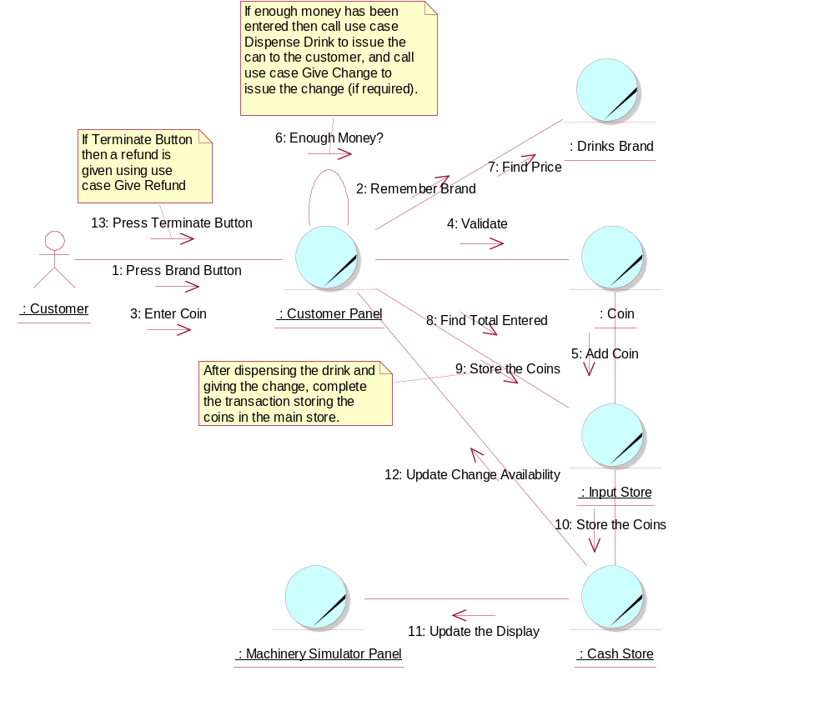

Participating Objects
: Cash Store
This is the repository for all Coins entered into the system. It is also where all change given to the Customer is taken from.
: Coin
The object stores the characteristics of coins entered into the system.
: Customer
This actor represents the customer of the vending machine (members of the general public) who would buy drinks-cans from the vending machine.
: Customer Panel
This panel simulates the vending machine's customer interface panel. It will enable the user (the Customer) to:
1 insert coins;
2 select brands;
3 terminate transaction.
It will also provide the following display functions:
1 display total money inserted;
2 indicate coin not valid;
3 indicate no change available;
4 display the value of the change to be collected;
5 display an icon representing the dispensed drink.

: Drinks Brand
This object stores the characteristics of the types of drinks can held in the system.
: Input Store
When Coins are entered into the Customer Panel, they are initially held in this store until the correct amount of money has been entetred by the Customer.
: Machinery Simulator Panel
This panel simulates the physical actions of the maintainer. It enables the user to:
1 display and enter new values for the number of cans of each Drinks Brand held by the Drinks Store;
2 display and enter new values for the number of Coins of each denomination held by the Cash Store;
3 display whether the vending machine Door is unlocked, and enable it to be locked.

Class Diagrams

Domain Class Diagram: Coin Input and Select Brand
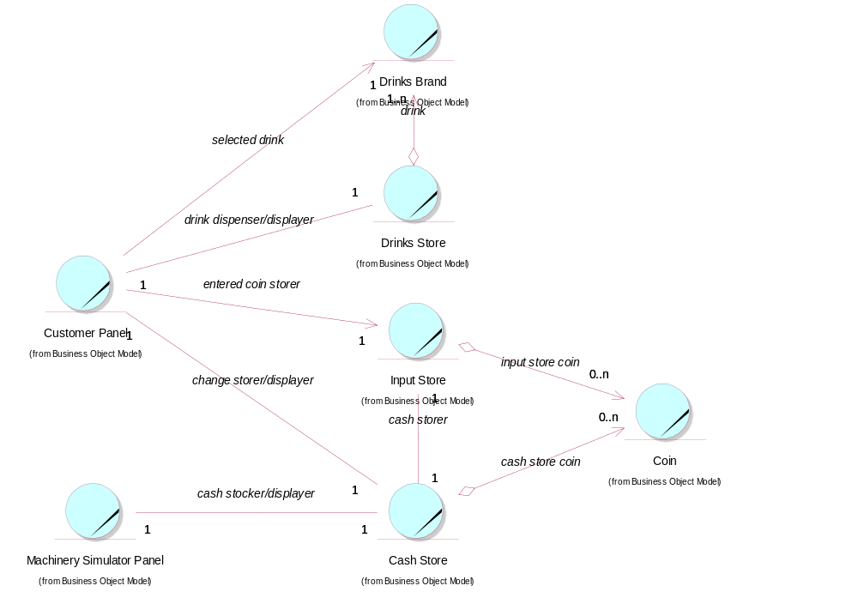

Derived Requirements
In the real vending machine, an input slot for entering Coins, and a cash tray for returning Coins will be required.

